
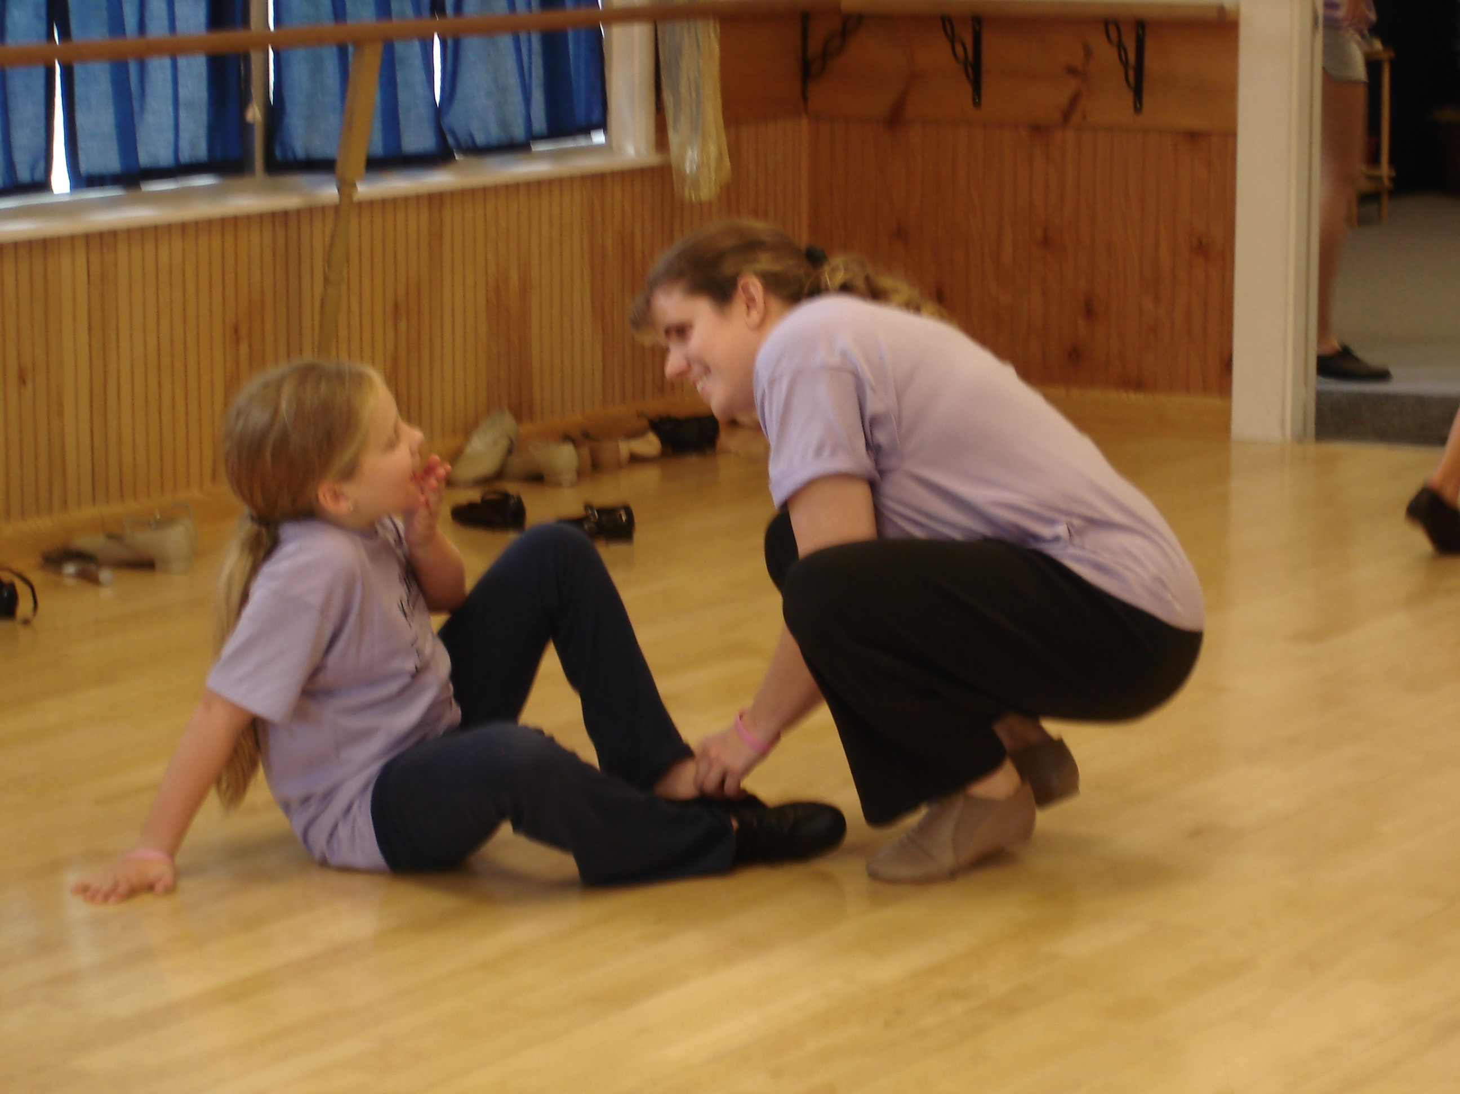
At Broadway Bound we provide the facilities, staff and options for a party that meets your requirements, makes your guests happy and doesn’t break your budget.
You can dance, sing, play games, tumble or just clown around!. You can play with critters, twirl a baton, or just lie around and watch a movie.
Or…if you want, you can just rent the space for a party of your choosing!

A party they will long remember!

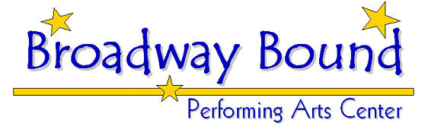

Tel: 429-8844



It’s party time
at

Broadway
Bound


501 Daniel Webster Highway
Merrimack, NH 03054
Phone: 603-429-8844
Or email:
broadwayboundpac@comcast.net
Create the party you want at a price you can afford!

Build your own party at

Broadway Bound!

At Broadway Bound we will help you create a party package that is both enjoyable and affordable. Our newly renovated studios provide spacious, clean and comfortable facilities for you and your guests.
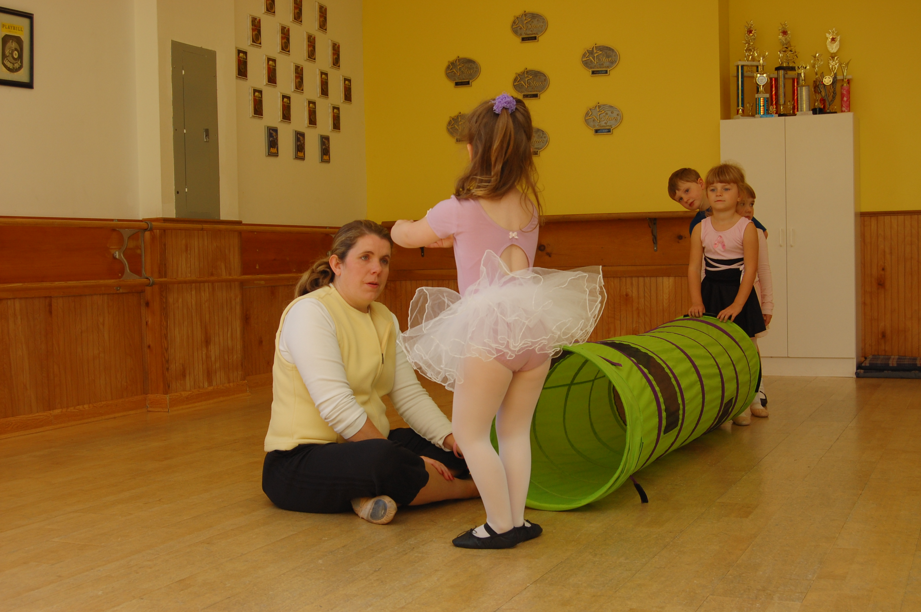
Parties may be created for all ages and occasions. If you have an idea we will help you turn it into a party.

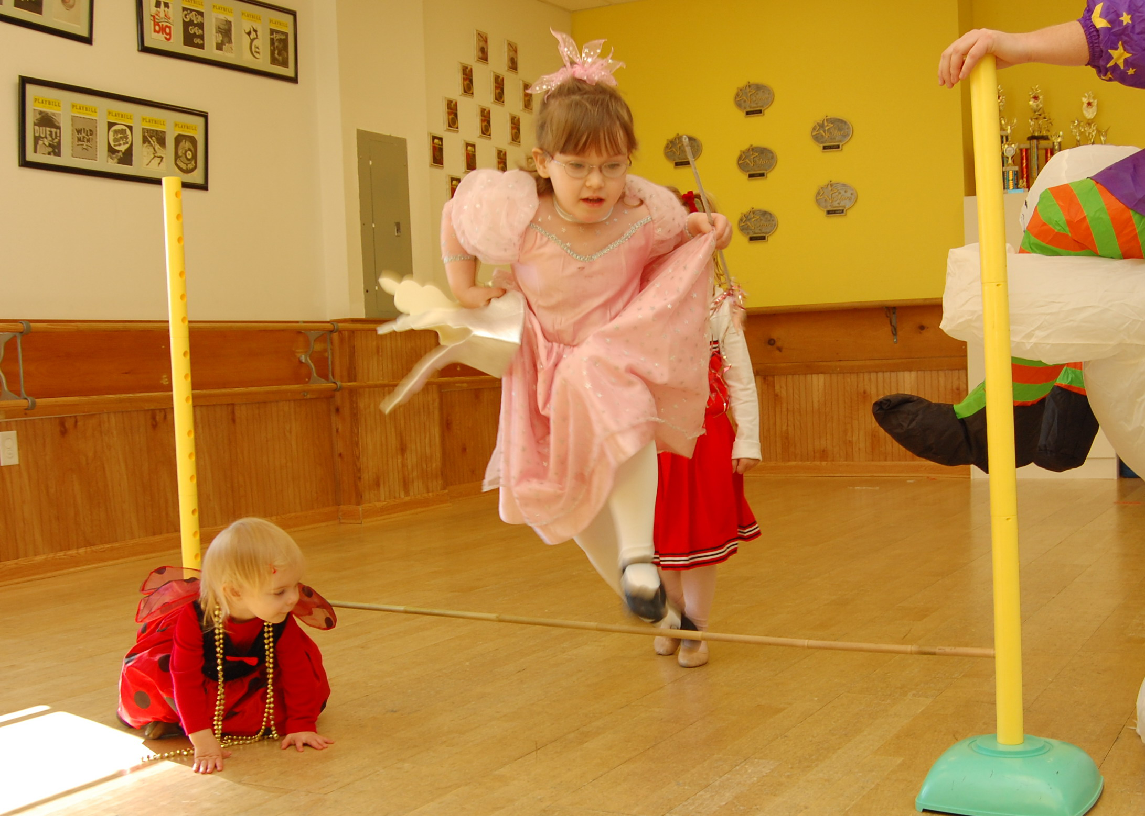
Parties are generally scheduled for the 2nd and 4th weekends of the month.
Tracey’s Boutique is a
one hour session of
make-up and makeovers!
Face painting, colored
hair gel, nail polish
designs, hair wraps,
braids with beads, 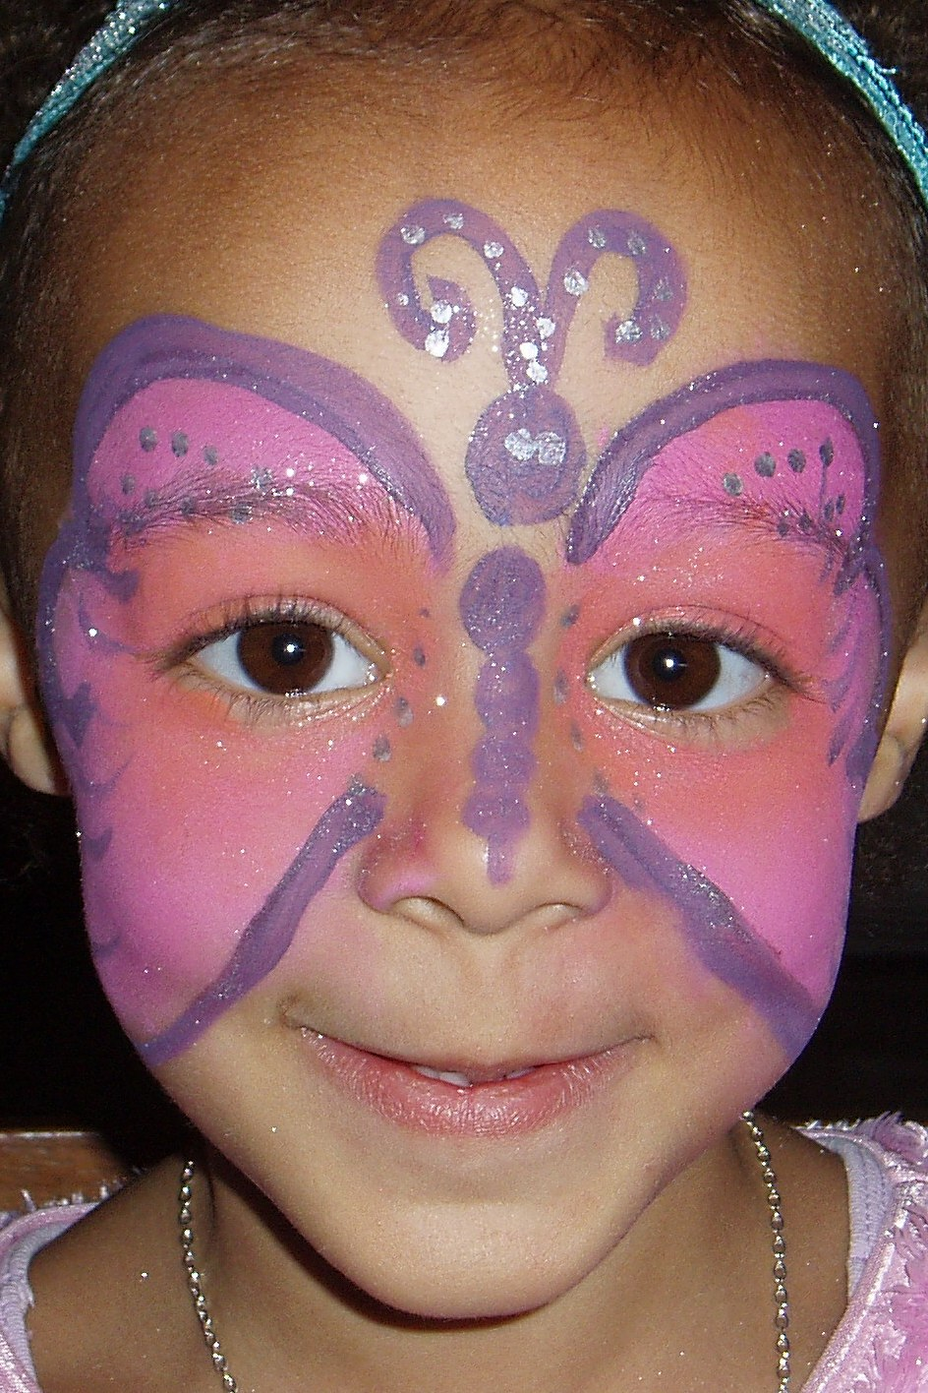colored
hair extensions, and glitter tattoos. It’s all
great fun!
$60.00 for a one hour session.
Critters and Creatures is a half hour
educational, hands-on live animal show
where guests will learn facts about the
animal “stars”. Entertainment combined
with education help make this a very
enjoyable experience. Each show can be
customized to meet your needs and is
led by a wildlife educator.
$125 for a half hour session.

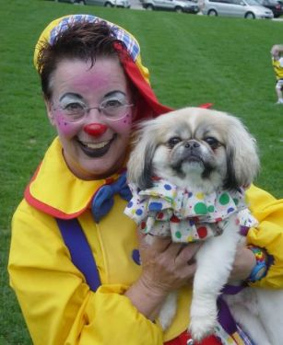Twinkle the Clown or
Cracker Jack will
spend one hour with
the party guests,
painting faces,
performing magic
tricks, making balloon
toys, performing with her
puppets and leading the group in fun and
games. Everyone loves a clown!
$150.00 per hour.

 There is a $150 party
minimum. Prices may
change without notice.

2010 Price List
(Prices are per guest)

The Basic Party Package is 2 hours of studio
rental, tables and chairs, downloadable invitations, thank you notes, a Broadway Bound t-shirt for
the guest of honor, and a free dance class
coupon for every guest.
$8.00
The Refreshment Package includes pizza, juice boxes and water, party plates, cups, napkins and utensils. A cake may be brought in by the host family or added at additional cost.
$5.00
At the Movies we will provide a DVD projector
and the popcorn. Attendees bring their own
sleeping bag or bedding. The host family will bring
an appropriate movie of their choosing.
$3.00
(The following prices are per party.

At the Dance Party Broadway Bound will provide
a teacher, music, exercise, games and age appropriate instruction in a dance genre of your choosing. Dance clothing or comfy casual outfits
are recommended for the attendees.
$75.00

Tumbling: Tots to Teens provides a teacher and basic instruction in tumbling and performance styles. Broadway Bound offers, a large room,
music and professional mats. Athletic attire is recommended.
$75.00

Twirling and Whirling is a one hour session of instruction in Baton Twirling and related dance movement. Broadway Bound will provide the
music, batons and instructor.
$75.00

